PRETTIE AND PRECIOUS KIDS

KINDERGARTEN AND CARE CENTRE

P.O. BOX 34146, KAMPALA – UGANDA

TEL: 0782-380651, 0772-517863, 0701-380651, 0701-517863

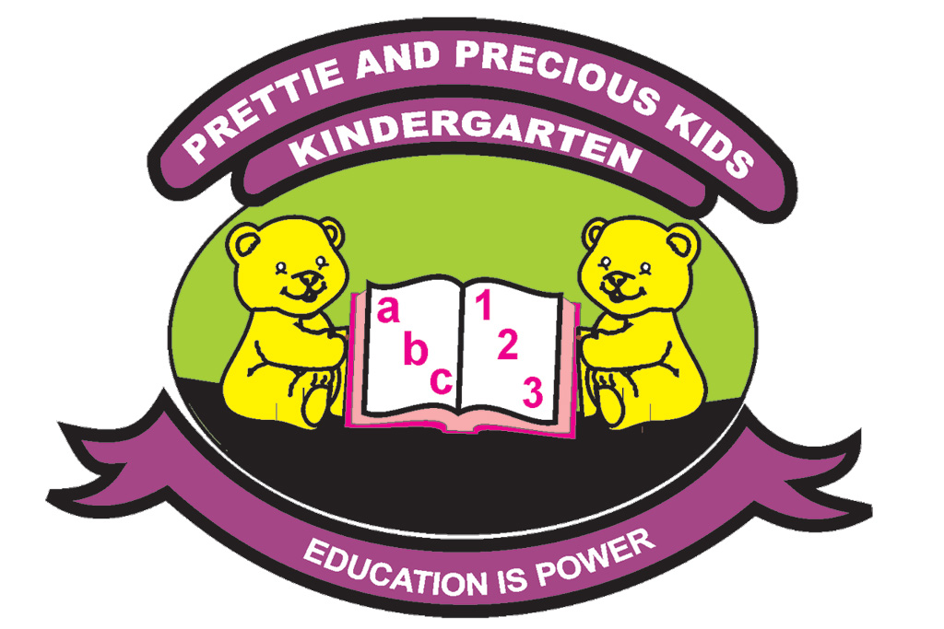

HOLIDAY ASSIGNMENT
TERM ONE 2024
BABY CLASS
Name:

NUMBERS

Match the same numbers.

1 5

2

3 1

2

5 3

Trace over number

Copy number 2

2
2

Colour number

Trace over number.

ENGLISH

Match the same pictures and draw.


Trace over a tin.

Write and draw
 |  | 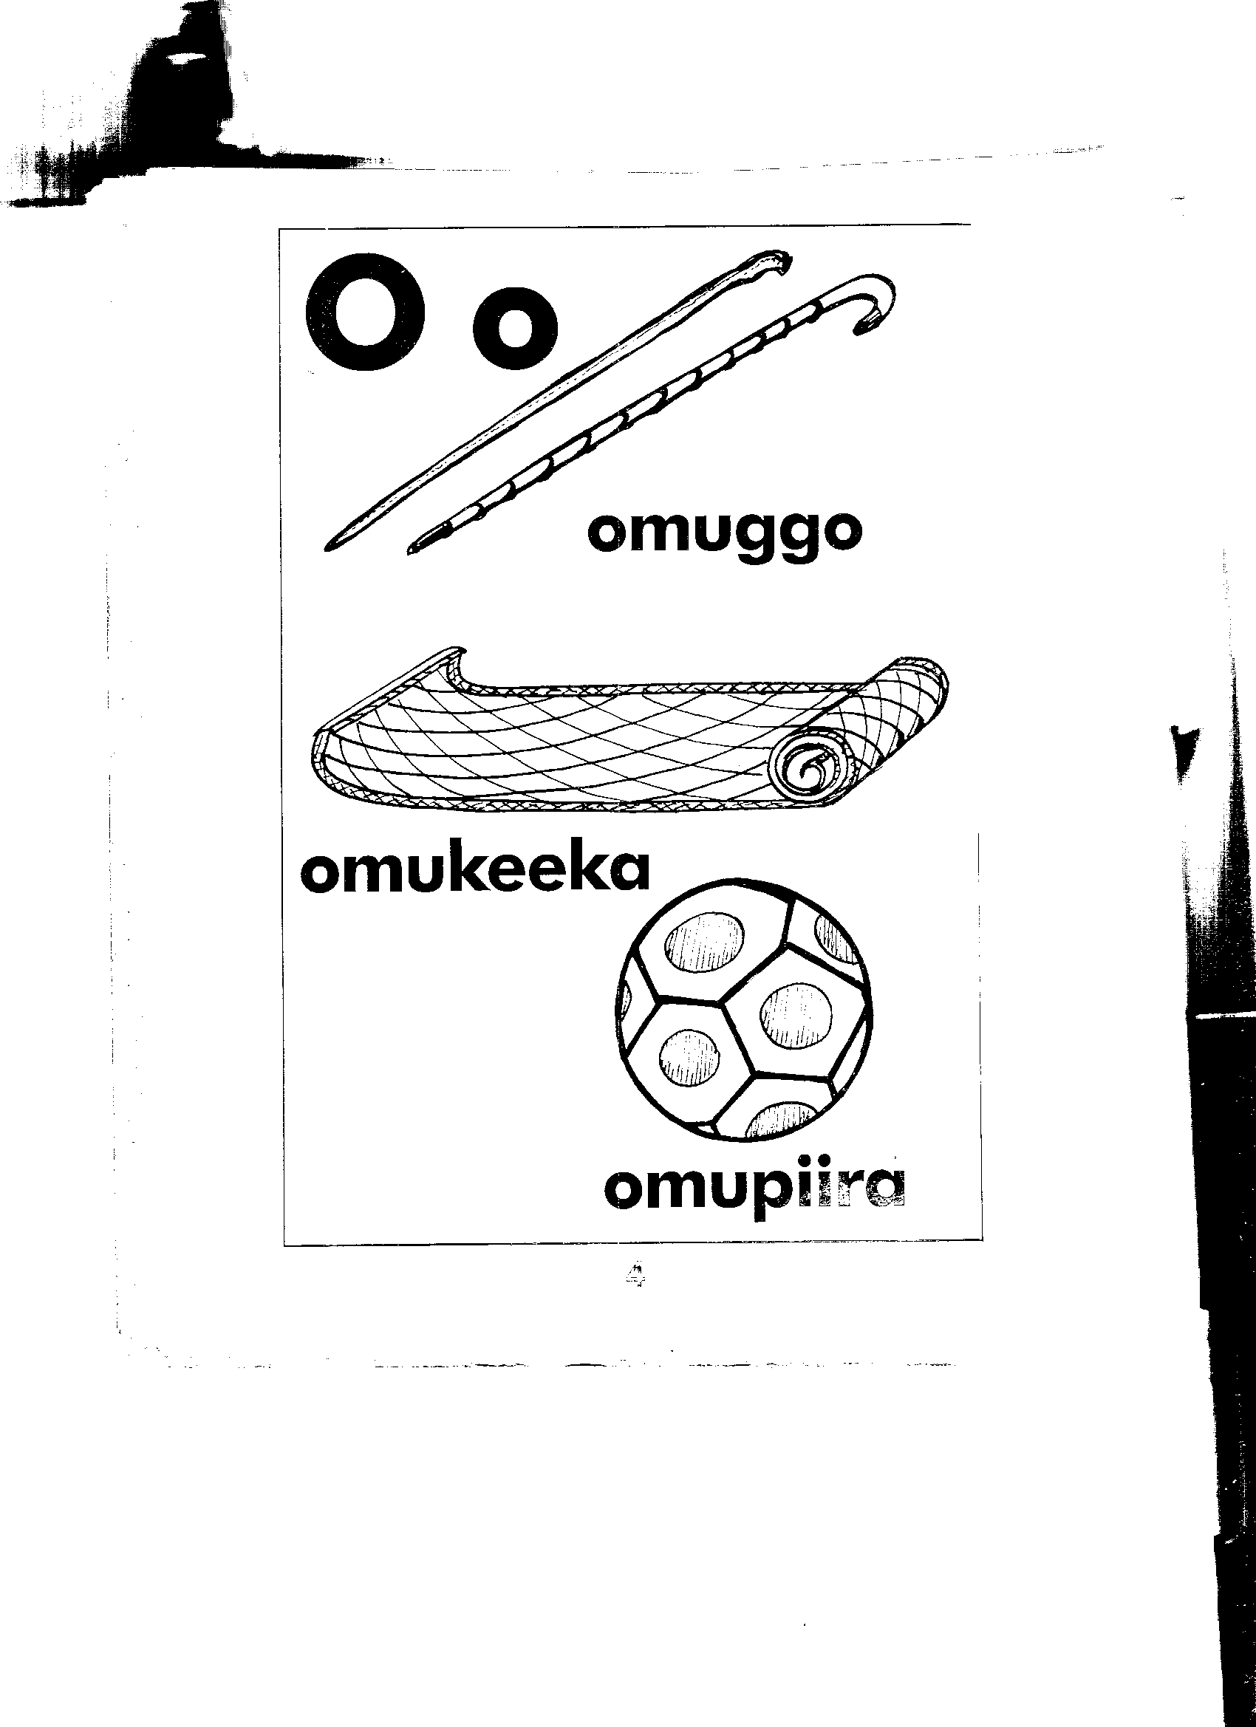


Trace a pencil.

SOCIAL DEVELOPMENT

Colour a dress.



Colour a skirt.


Colour father.
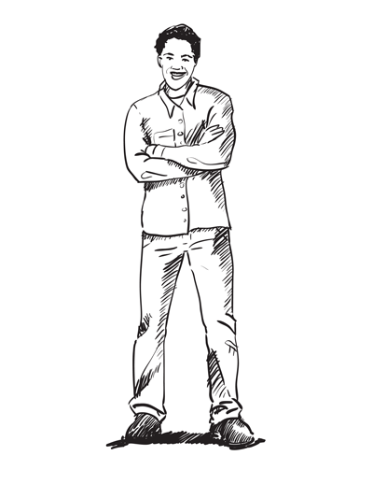

READING

Match the same sounds.

S i

a t

t a

i s

Trace over sound s.

Colour the sound and it’s picture.





Trace over the sound .

Copy these sounds.
a | a | a | a
i
i
i
i
i

i
i
i
i

Colour the sound and it’s picture.
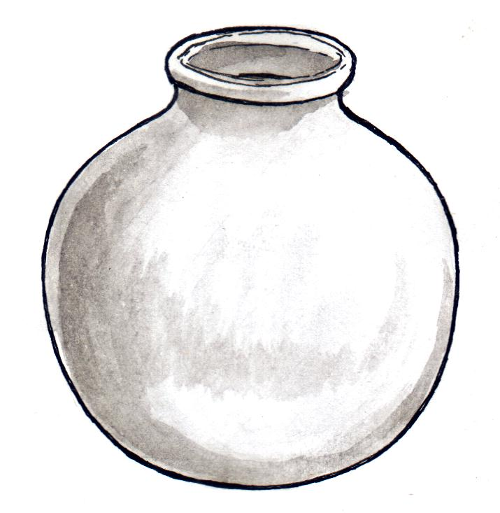

HEALTH HABITS.

Colour the figures.


Colour the eye.



Colour the hand.

Match the same body parts.





HAND WRITING

Copy a curve forward.

Copy a standing stick.

